Final Model
one Encoder shared by all classes
Our latent space is a GMM.
Each class gets encoded into a learnable prior. Each class has its own mu and var. Each class is a Gaussian. MMD-loss (train encoder= latent space embedding + gaussians’ mu and var)
Embeddings are also used by NN-kNN, in training with classification loss.
NN-kNN is using Mahanalopis distance.

TODO:: need to figure out how to make a program to make test easily for MTurk

Final Design about Case-based Interpretability Human Subject Study
We will compare the following models:
There will be three kinds of survey questions. (We try to keep the surveys simple and straightforward)
We will be comparing the explanation results from various models in each of the survey questions. The participant will not know which model is being used. The participant will only see the query case, the retrieved explanations, and will be prompted a question.
All tests should be preluded with a description like the following: “We built an AI model that classifies a query image by retrieving a stored image and reusing the label of that image. For example, the AI model will classify an image as a submarine, by finding a similar image of another submarine. We want to evaluate whether two images are considered similar enough to human eye, or whether one image can be similar enough to justify the classification of the other.”
- Comprehensibility Test
We choose a k value starting from 0 to 100, in increment of 10, each value is chosen once. Then for each k, we randomly generate a set of questions. Each question is composite of 2 pictures: a query picture, and the k-th neighbor picture retrieved by a certain model X. The participant will answer a yes/no question “For the query image on the left, the model retrieves a case on the right and makes a prediction based on this retrieved case. Do you think the retrieved case can justify/explain the model’s decision?”
“Do the two images look similar to you?” (divide class, and visually similarity)
(yes, somewhat yes, somewhat no, no,)
(The user does not need to know the actual target label or the class prediction, the user just need to decide whether the retrieved case is appropriate as an explanation)
If the user choose yes, then the model X receives 1 score, otherwise, 0 score.
We will be able to generate a 2-d trend graph, with the X-axis being the value k, and the y-axis being the average final scores. We will show a trend line, representing the average score of a model X for each value k. Supposedly, for all models, this trend should start high and go down. The ideal result is that our model will have a trend that goes down slower than other models.
- Diversity Test
This is an extension of the previous test. After a model retrieves multiple cases for a given query, we will randomly sample two (correct label) cases from the neighbors. And then ask the user, are these two images similar?
“Do the two images look similar to you?”
If the user chooses yes, then the model gets 0 score, if the user chooses no, then the model gets 1 score. The goal is that, if a model retrieves diverse set of neighbors (correct class), then the score will be very high.
Normally, if a model is good at retrieving diverse set, its retrieved cases may not get high comprehensibility score. However, we don’t rule out the possibility that a model gets high comprehensibility and high diversity scores.
- Comparison Test
We also choose a k value starting from 0 to 100, each value is chosen once. For each k, we choose two models for comparison. Each pair of models is chosen once. Then we generate a set of questions. In each question, the participant will be presented with a query image, and two k-th neighbor images found by the two models (one from each). The participant will be prompted with the question. “Which of the two neighbors are better explanations for classifying the query”. The participant can choose, “first, second, or they are equally good”
If the user chooses first, then the first model receives 1 score; if the user chooses second, then the second model receives 1 score; if the user chooses equal, then both models receive 0.5.
Once we collect the results, we can also generate a similar 2-d trend graph like in experiment 1, with the X-axis being the value k, and the y-axis being the average final scores.
This trend line will show side-by-side comparison scores from pair comparisons.
Alternatively, we could do a comparison experiment where participants rank the explanation cases from multiple models all at once (not just two models). But I think I would prefer this simpler version, less cognitive load on the participants and I think the results will be more reliable/stable.

About Case-based Interpretability
There is no single standardized metric for case-based interpretability yet, but several agreed-upon principles and emerging evaluation methods are cited across the literature—particularly in the context of CBR and prototype-based neural models. Based on your work and the ICCBR 2024 paperICCBR_24_Combining_Inte…, here's a synthesized view of how case-based interpretability is (or can be) measured, with references and implications for your GMM NN-kNN model.

✅ Established Criteria & Emerging Measures for Case-Based Interpretability

1. Case Fidelity / Alignment (DONE)
- Definition: How often the top activated cases support the final prediction (e.g., match the predicted label).
- Metric: Top-k agreement rate between neighbors and predicted class.
- Status: Used in your ICCBR 2024 evaluation (e.g., "accuracy with top-k selection enabled" approximates this)ICCBR_24_Combining_Inte….
- Interpretability Angle: Ensures that explanations (cases) are faithful and intuitive to humans.

We can do this. This is an easy extension of our current nearest misclassification.

2. Exemplar Clarity
- Definition: Whether the retrieved/activated cases are easily understood by humans and recognizable as real examples.
- In Practice:
  - Avoid "prototype blending" or "synthetic artifacts" (critique of prototype models like ProtoPNetICCBR_24_Combining_Inte…).
  - Favor actual training cases (which NN-kNN does), making explanation more trustworthy.

This would be meaningful if we have hard data sets. Maybe not right now?

3. Neighbor Sensitivity / Stability
- Definition: How sensitive the model's prediction is to small changes in activated neighbors.
- Metric: Leave-one-neighbor-out (LONO) or influence function.
- Interpretability Angle: Highlights robustness and reduces suspicion of spurious explanations.
We can do the David Leake’s version of this, by perturbing a query slightly, and measure the jaccard similarity of the top neighbors before and after perturbation.
On second thought, we won’t be able to do 5, we will do 3. this one here.

4. Case Relevance and Sparsity
- Definition: Whether only a few highly relevant cases contribute significantly to the final decision.
- Metric:
  - Case activation sparsity (e.g., top-k covers >90% of the activation mass).
  - Entropy of the case activation distribution.
- Why It Matters: Sparse, focused explanations are more interpretable and aligned with human reasoning.
We can do this. In our case, we can show a bar graph representing case activation sparsity, and also show entropy. This would only make sense if we are comparing the various models using NN-kNN. Because their scale would make sense to each other (case activation values). Otherwise, if we compare NN-kNN and non-kNN methods, we are risking comparing apples with bananas.

5. Explanation Consistency
- Definition: Are similar queries explained by similar cases?
- Test: Group semantically similar inputs and compare activated neighbors using:
  - Jaccard similarity of neighbor sets
  - Cluster stability over latent embeddings
- Status: Rarely evaluated directly but important for trust in deployed systems.
We can do this: for each query Q, we can find its nearest neighbor A, and find its neighbors N(A) and compare that with N(Q). Using jaccard similarity.
On second thought, we cannot do this, because if we use the nearest neighbor A in our NN-kNN. It is going to highly activate the case A itself, as it is part of the case base. We will do number 3 instead

6. Human-Centered Evaluation
- Definition: Do users find the case-based explanations helpful?
- Method: User studies, such as:
  - “Does this case help you understand the model’s decision?”
  - “Would you trust the model’s output after seeing this explanation?”
- Cited: [Gates et al., 2023] show how user trust correlates with similarity of shown casesICCBR_24_Combining_Inte….
We can’t do this right now. It would only make sense we if we have a meaningful dataset/task, with a meaningful group of human participants (who knows the task). For example, a group of psychologists looking at cases suggested for the task of mental health diagnosis.
We decided to do either Omniglot or the Chinese characters. I prefer the Chinese characters because then we can interview experts and non-experts on the recommendations made by the models.

7. Internal Attribution Traceability
- Definition: Can we trace how each feature and case contributed to the final prediction?
- In NN-kNN: You have built-in interpretability via:
  - Feature-wise distances
  - Case activations
  - Final label contributions via w(x, L)
- Metric Idea: Produce saliency-style visualizations of feature + case contributions.
We can do this? But would it be meaningful? This is not particularly related to case-based interpretability. We could do a feature saliency visualization on some specific examples, to show that our method is compatible with the feature saliency explanation methods. However, this wouldn’t be the main point of our paper, just showing that it is compatible.

🔍 Summary Table
Criterion | Type | How to Evaluate
Case fidelity/alignment | Quantitative | Top-k match rate
Case relevance/sparsity | Quantitative | Activation entropy, mass coverage by top-k
Explanation consistency | Quantitative | Neighbor overlap for similar queries
Case exemplar clarity | Qualitative | Human inspection (real vs. synthetic)
Influence and stability | Quantitative | Leave-one-neighbor-out perturbations
Attribution traceability | Structural | Inspect feature weights, w(x,L), and case activation logic
Human utility/perceived trust | Qualitative | Human subject studies, surveys

Would you like help designing one or more of these as a reproducible metric or visualization for your paper or experiments?

My note about case-based interpretability

TODO

Exploring the Trade-Off in the Variational Information Bottleneck for Regression with a Single Training Run
“Researchers have proposed methods like the Variational Information Bottleneck (VIB) to introduce a probabilistic latent in an encoder-only setting: VIB adds a KL-divergence term on the encoder’s output (just like a VAE encoder, but without a decoder) to force it to compress information, improving generalization and providing a notion of uncertainty in the latent”

DOING

ArcFace
1801.07698

DONE

ImageNet-HSJ
Enriching ImageNet With Human Similarity Judgments and Psychological Embeddings
“Of particular note is recent work that collected similarity judgments for 1,854 unique images belonging to the THINGS dataset [17, 18].”

Thing project, their similarity judgement measure is doing something similar to my comparison test.
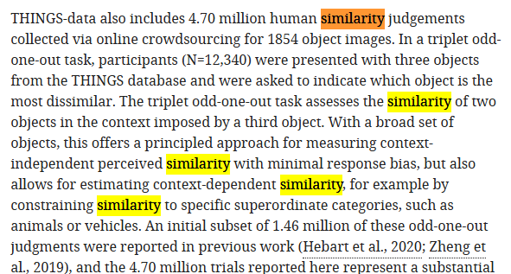

GWAE
2209.07007
skipped for now.

Exemplar VAE
Exemplar VAE: Linking Generative Models, Nearest Neighbor Retrieval, and Data Augmentation
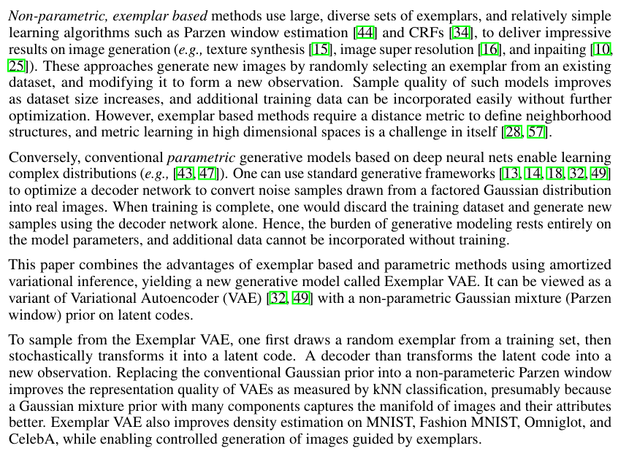
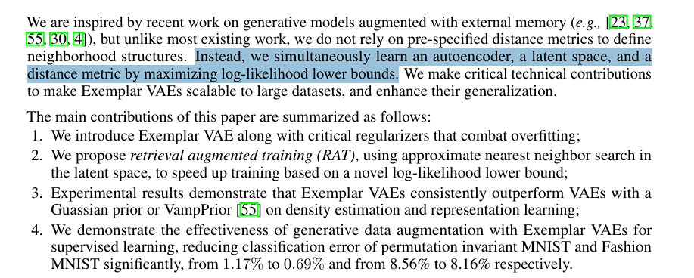
Our WAE+NN-kNN is doing a similar thing, we are learning an autoencoder, a latent space, and a distance metric at the same time, by maximizing recon-loss, WAE-MMD loss, and classification loss of kNN.

Our contribution are:
- we use MMD to regularize the latent structure to be smooth and compact. MMD additionally prevents model collapsing. This latent space make NN-kNN more robust, instance-reasoning is now probabilistic instead of on points.
Experiment 1: We can show this by showing accuracy benefits of GMM + NN-kNN over other models. (see section “models to compare with”)
Experiment 2: To show the robustness, we can corrupt our data sets and see how well different models perform.
- We now have an additional explanation method by generating samples from the latent space, using decoders.
Experiment 1: we can show the explanation of nearest neighbor, just like what we did in our previous NN-kNN (see pic below). Very likely the new explanations by WAE + NN-kNN is better, if it is going to achieve better accuracy in the experiment above.
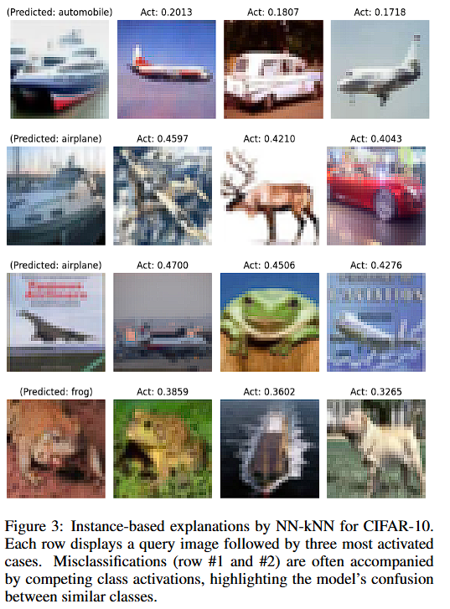
Experiment 2: Because latent space is now smooth and compact and we have a decoder, we can show interpolation between the query Q and nearest neighbor C retrieved, by gradually modifying C into Q, and decode each embedding into images, to show an interpolation. Experiment 1 and 2 can be combined, as a method for explanation.
Experiment 3: Novel query or anomaly detection. We can use NN-kNN’s distance, to show when a query is far from all cases. From the WAE side, we can use FID score, show the discrepancy between query q and its reconstructed version D(E(q)), where E is encoder and D is decoder of the WAE. I am not sure how other people do this, might ask ChatGPT. This is cool because now we can use novelty detection from both WAE and kNN side. Maybe they agree with each other.
- NN-kNN adds local/instance-level reasoning to this latent space, similar cases or cases of the same class will share similar embeddings, and learns a metric with feature weights and case weights. This also adds case-based interpretability.
Experiment: we can show something like this, supposedly we should separate classes very well.
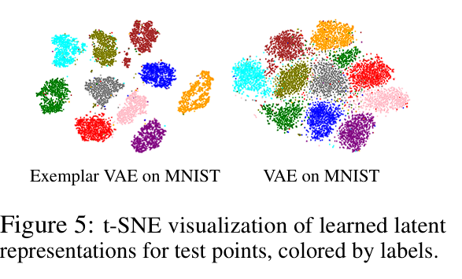

Wasserstein Auto-Encoder WAE
Wasserstein Auto-Encoders | OpenReview
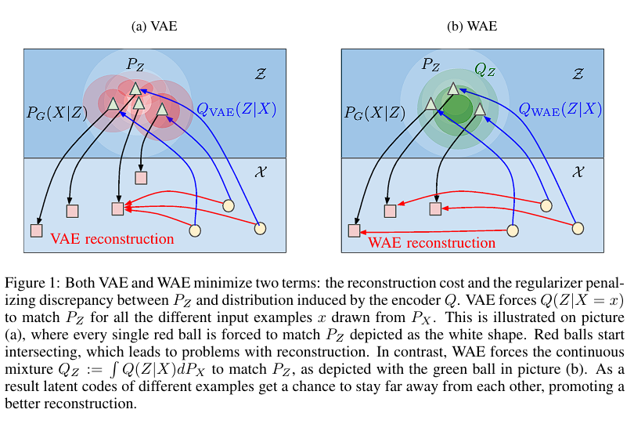
From their related work discussion, difference between VAE and WAE

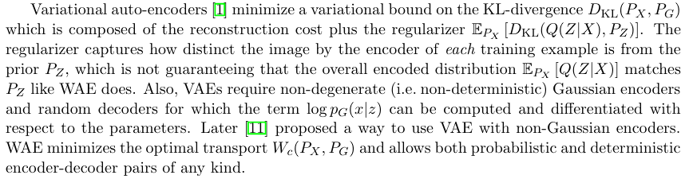

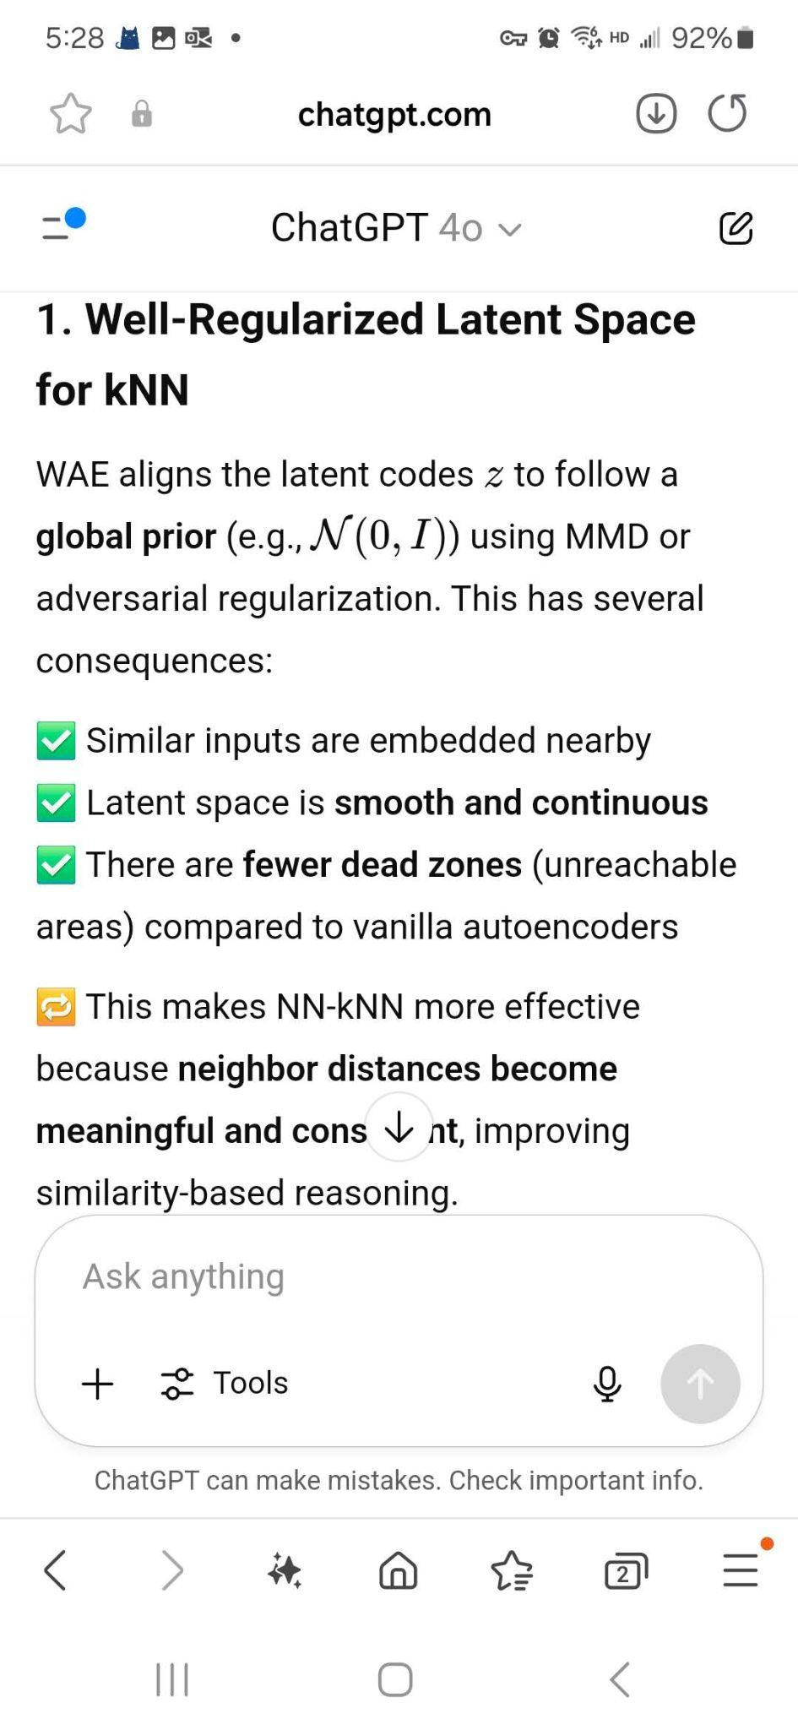
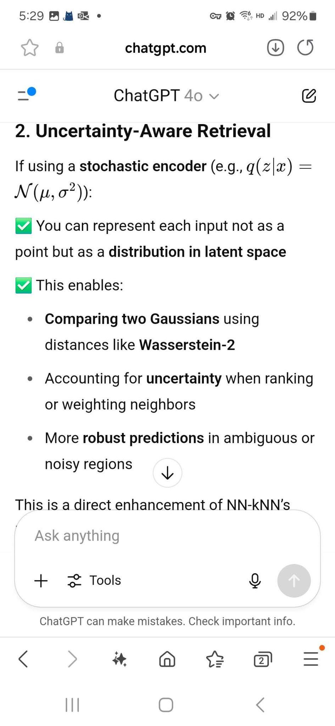
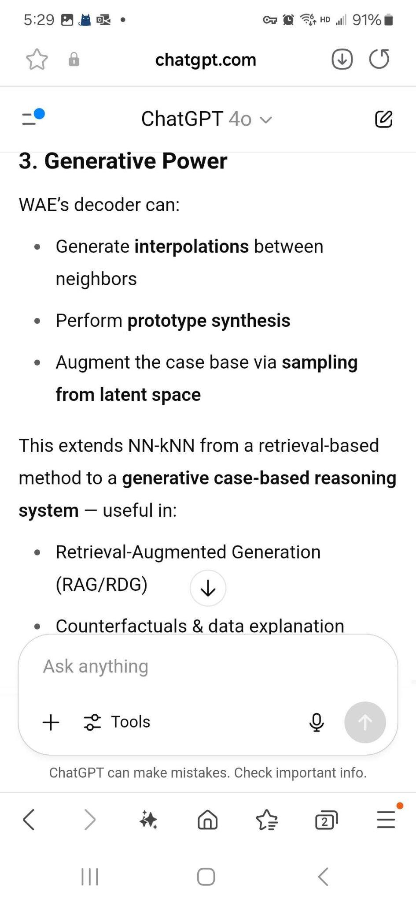
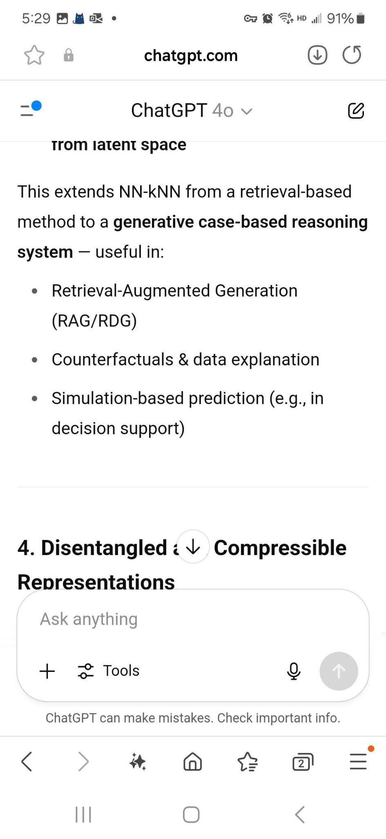
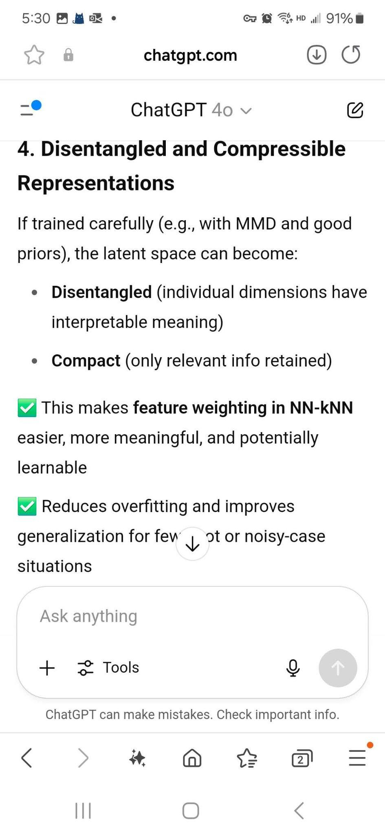
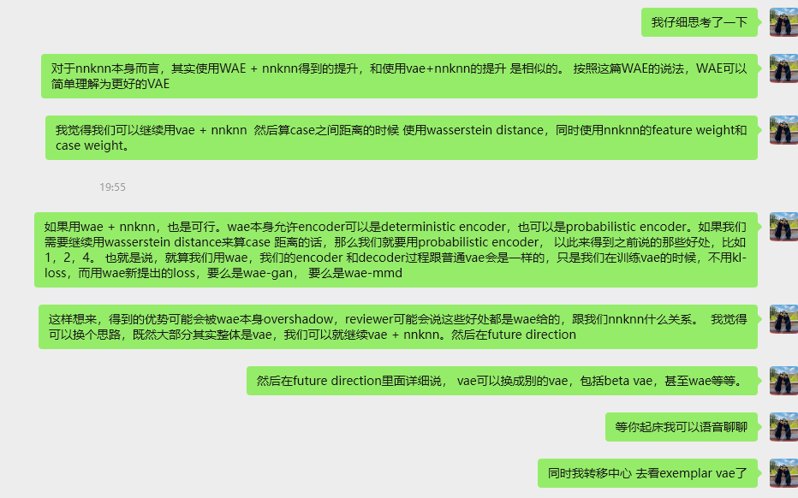

Dataset:
Yu had a list of data sets

Models to compare with:
VAE + NN-kNN, train together with Recon Loss, KL-loss, classification loss
VAE pretrained, use with standard kNN (no training, non-parametric)
VAE pretrained, then train Encoder with NN-kNN
Encoder + NN-kNN, train with KL-Loss, classification loss
“sufficient data is available, a purely supervised
encoder (Approach 2) often slightly outperforms an
autoencoder-based model on the same task, because the au-
toencoder might waste capacity on reconstructing details ir-
relevant to classification.”

benefit of Encoder + NN-kNN
VAE has disentanglement ability (beta VAE, KL-loss has the benefit of regularization, and disentanglement: The covariance matrix is the identity: Σ=I\Sigma = IΣ=I, i.e., all latent dimensions are independent and have unit variance)
KL-loss handles feature scaling too because all features are mapped into that small gaussian ball.
NN-kNN selects features and weights features
probabilistic

Future direction:
KNN can do some anomaly detection, according to the notes below, if we add decoder, we can also train the VAE for anomaly detection:

“Thanks to the unsupervised component, autoencoder-
based approaches can utilize unlabeled data for representa-
tion learning. This can be advantageous when adapting to
new domains: one could fine-tune the autoencoder on unla-
beled examples from a new domain to capture its structure,
then use the updated encoder for classification. The presence
of a decoder means the model has learned a more general
data distribution, which can help detect anomalies or novel
classes (inputs very different from training data would re-
construct poorly, signaling they lie outside the learned manifold)”

protoNet
Deep Learning for Case-Based Reasoning through Prototypes: A Neural Network that Explains Its Predictions
Related.
Discussed with Yu. They are forced to use VAE (with decoder) otherwise the prototypes might be meaningless.

ProtoPNet
1806.10574
Highly related, from Cynthia Rudin’s group
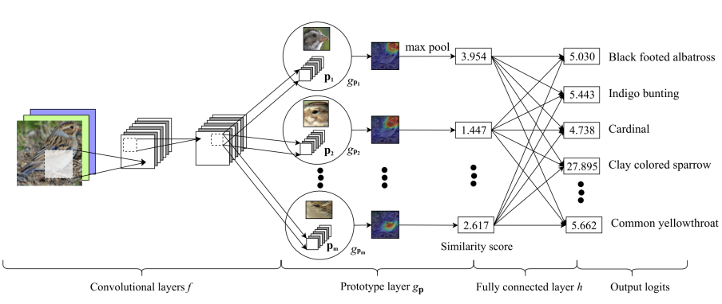
One thing worth mentioning is that they had to do some special training about their end-to-end network. In the paper, section “2.2 Training algorithm”, they mentioned that they used stochastic gradient descent SGD of layers before last layer, and the last layer h, is the layer that prototypes contribute to final classification. They set a starting point for that layer like what we did,
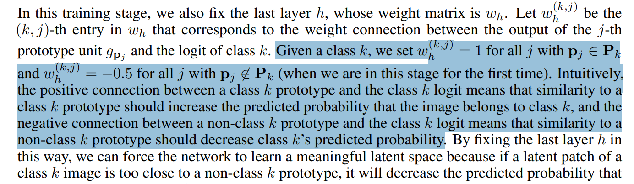
Because the prototypes are learned, they are not real and cannot really be used for explanation. So instead, what they did was that they actually find real training samples close to the prototypes (after feature extraction), and then use those samples for explanations as if they are prototypes.
In this paper, they only have a qualitative visualization of how the explanation works. They don’t really have a good way to measure the explainability of their system.

wasssertein intro
A Short Introduction to Optimal Transport and Wasserstein Distance · Its Neuronal
A good intro to the distance, explains the problem really well.
However, didn’t explain how the formula for the Wasserstein distance for Gaussians come into being.

It seems that the simplified formula only works if the Gaussians are isotropic
definition - Gaussian distribution is isotropic? - Mathematics Stack Exchange
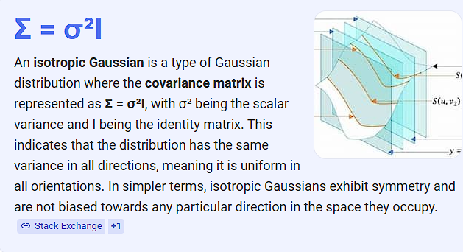

So, are our gaussian isotropic in VAE?
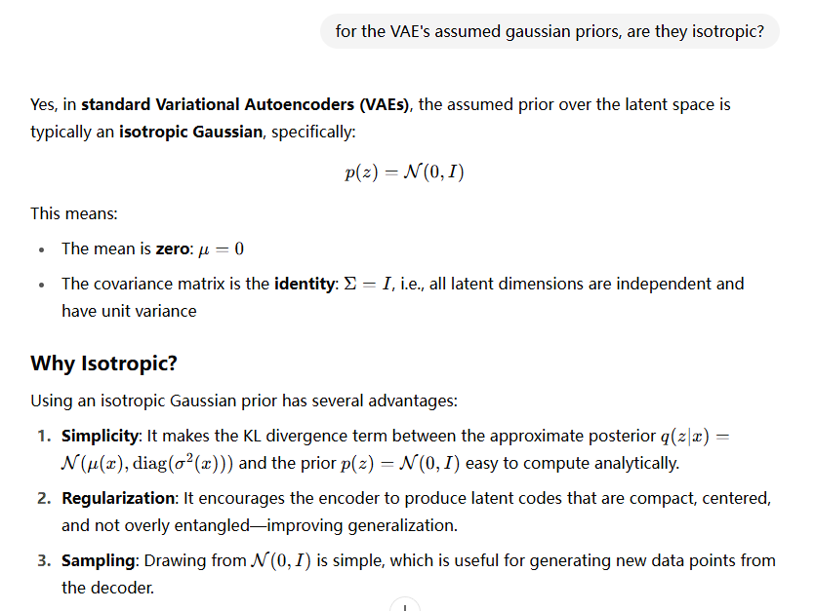

New Wasserstein Distance

